

**Boston University**

**Electrical & Computer Engineering**

**EC464 Capstone Senior Design Project**

**User's Manual**

Luminesense



Submitted to

Professor Thomas D.C. Little

Boston, MA

(617) 353-9877

[tdcl@bu.edu](mailto:tdcl@bu.edu)

by

Team 1

Adaptive Gesture Based Lighting Systems

Team Members

Caroline Jones [ctjones@bu.edu](mailto:email1@bu.edu)

Michael Haley [mhaley10@bu.edu](mailto:email1@bu.edu)

Sneha Pradhan [snehha@bu.edu](mailto:email1@bu.edu)

Tanatsigwa Hungwe [hungweta@bu.edu](mailto:email1@bu.edu)

Zehua Zhao [zehuaz@bu.edu](mailto:email5@bu.edu)

Submitted: April 7th, 2017

#### Luminesense

#### Table of Contents

Executive Summary ii

1 Introduction 3

2 System Overview and Installation 5

2.1 Overview block diagram 5

2.2 User interface. 8

2.3 Physical description. 9

2.4 Installation, setup, and support 10

3 Operation of the Project 12

3.1 Operating Mode 1: Normal Operation 12

3.2 Operating Mode 2: Abnormal Operations 14

3.3 Safety Issues 15

4 Technical Background 16

5 Cost Breakdown 19

6 Appendices 20

6.1 Appendix A - Specifications 21

6.2 Appendix B – Team Information 21

# Executive Summary

Lighting systems have failed to take advantage of the opportunities presented by IoT technology - a world of intelligent, interconnected devices. Nowadays, consumers need a lighting system that is more dynamic, intuitive and conscious of energy consumption. Luminesene’s final deliverable is a lighting system solution that consists of a wearable transceiver, light fixtures, an IP enabled central hub, and single pixel cameras.

The system engages with the user in two different modes: “gesture mode” and “adaptive mode”. The former allows the user to actively interact with the system and explicitly change the properties of the light fixtures - their colors and brightness - by invoking gestures through the wearable. The central hub analyzes information regarding the selected lights, recognizes the gestures sent from the wearable, and updates the states of the lights. The second mode hosts a passive interaction between the user and the system. The system acts as a traditional IR sensor - turning the lights on in the presence of a user, and turning them off in the absence of a user. The single pixel cameras detect the presence of users, and relays this information to the central hub, where the lights are updated.

In the midst of all the interactions, the system’s energy consumption and performance data is logged into a database and displayed on a web application. This portal grants the user access to energy usage graphs, where they can track their energy usage over periods of time. Additionally, the application gives the user remote control over the system - allowing them to change gesture preferences and issue commands to luminaires without using the wearable.

The Luminesense system features a host of capabilities: an accurate gesture recognition system, a comfortable wearable device, an intuitive gesture library, and a state of the art motion capture system that adjusts lights in real time. The project is not exceptional by virtue of its objective, but by the execution of its objective: to create a unified system of communication amongst the various components. In doing so, the system redefines the way humans interact with lights and provides a new energy efficient paradigm for smart lighting systems.

# 1.0 Introduction

The problem our client faces is the need for a dynamic, convenient lighting system that can intuitively respond to user preferences and commands using a wearable that is fully integrated with their existing luminaire technology. Furthermore, there is a need to improve the energy efficiency in current lighting systems, which offer no control over the number or intensity of lights that are on in a room; therefore, Luminesense automatically adapts to energy-saving protocols based on the presence of occupants in the room.

As the “Internet of Things” (IoT) phenomenon emerges and an increasing number of everyday objects have network connectivity, lighting systems continue to lag behind, failing to become “smarter”. The standard light switch has existed for over 100 years and is still highly limited in its functional capacity (typically just “off” and “on”). This is clearly a market that could reap great benefits from IoT technology.

From an environmental perspective, humans are depleting electricity, a critical resource, at an alarming rate. By carelessly leaving the lights on in an unused room, the average consumer produces an additional 0.15 pounds of greenhouse gas emissions per hour. These greenhouse gases trap heat in our atmosphere and contributes to climate change that has the potential to compromise our way of life. This type of reckless behavior wastes money, energy, and has a negative impact on the environment.

Our project centers around a wearable that is fashioned from an Arduino 101 and Intel Curie chip with which a user can interact seamlessly with the customer’s existing luminaire technology. The luminaires house an LED and are connected via Wi-Fi. Additionally, these luminaires have a wattage of 12, which is much less than the standard 60-watt bulb. The wearable enables the user to use gestures to interact with the lighting, which provides convenience and more precise control over lighting than any other system. The project also switches between gesture and adaptive modes automatically in order to save energy. For example, when a user leaves the room without gesturing to turn the light off, the adaptive mode will take over and switch the lights off in order to prevent energy waste.

Special Features:

1. Wearable transceiver with Bluetooth capability

2. Comprehensive gesture library to support user control over lighting fixtures with accompanying gesture dictionary that explains all possible gestures

3 Web application monitoring performance data and energy savings

4. Control software designed to accomplish three tasks:

* Recognize the location of the user(s) utilizing the wearable device.
* Analyze the information being sent amongst the Raspberry Pi, the luminaires and the user i.e the gesture and the light codes.
* Control the states of each individual luminaire within the system.

5. Occupancy detection driving adaptive mode control

In the proceeding sections of this document, various aspects of the system will be detailed, including in-depth system information, block diagrams, instructions for correct operations, safety information, cost breakdown, technical background, and additional information about the project and the team.

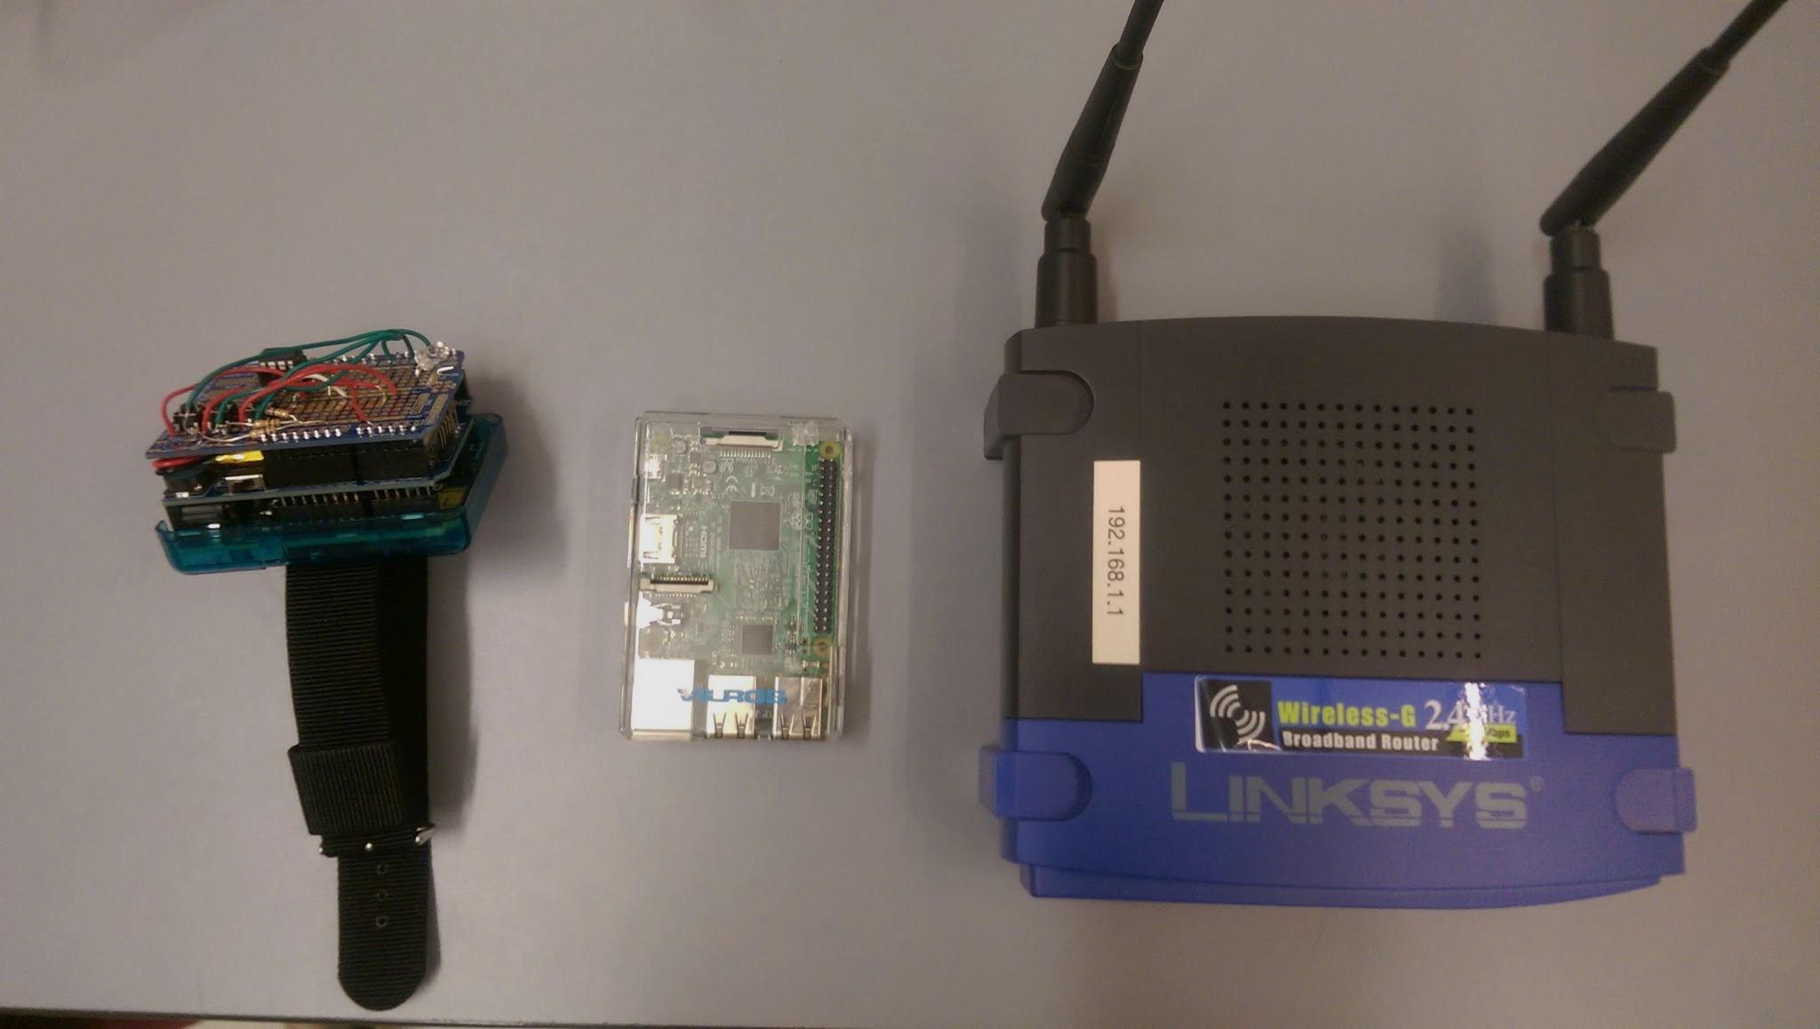

*Figure 1: Wearable, Central Base and Router*

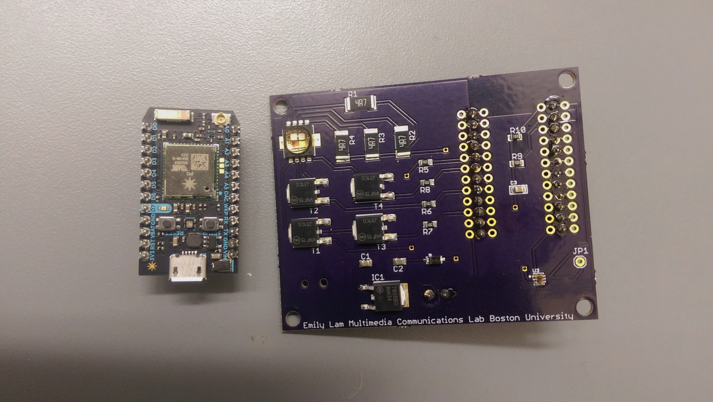

*Figure 2: LED and Photon*

# 2.0 System Overview and Installation

The Luminesense system consists of five major modules: the wearable transceiver, the central base, the luminaires, the single pixel cameras, and the web application. Their integration amongst each other depends on the current mode of engagement - “gesture mode” or “adaptive mode”. The system block diagrams below illustrate the different hardware interactions.

In the gesture mode: the user utilizes the wearable to control the session, select luminaires and perform gestures to alter the lighting arrangement. This active interaction is facilitated by the central base. In adaptive mode: the cameras observe the occupancy status through the thermal sensors in the room and update the lighting accordingly. In this scenario, the user either has no wearable or is no longer present in the room. Similarly, this passive interaction is facilitated by the central base. Additionally, in either mode, the user’s interactions with the web application do not change.

## 2.1 Overview block diagram

## Wearable Transceiver

The transceiver consists of the following: an Arduino 101, a 6-axis IMU, a Bluetooth Low Energy (BLE) module, a photodiode, three push buttons, and a battery pack. This device is responsible for all interactions between the user and the system (in gesture mode). The Arduino contains a C program required to utilize the additional peripherals. The program samples light signals, performs Fast Fourier transforms (FFT), samples IMU signals, polls button states, and sends data (of size 4 bytes) via BLE. The Arduino contains 196 kB Flash memory and 24 kB SRAM - sufficient to execute computationally complex instructions in reasonable time. The board’s operating voltage and I/O is 3.3V but can tolerate up to 5V. In adaptive mode, the wearable is not used to interact with the system at all.

## Central Base

The base consists of a Raspberry Pi 3 (Ras Pi) - connected to a router - and is responsible for the system’s data aggregation. The Raspberry Pi contains a BLE module, Wireless LAN, 1GB RAM, and 1.2GHz CPU - necessary for multiple data transactions between the transceiver, luminaire(s), cameras, and web application. Upon booting, the Raspberry Pi runs a JavaScript program to scan and pair with the transceiver via its BLE peripheral address (in gesture mode). After doing so, the base receives all the ID, button, and IMU data sent from the transceiver. Subsequently, the base applies the data and implements the desired commands sent from the user. These commands are relayed to the luminaire(s) and logged into the web application’s database via Wi-Fi. In adaptive mode, the base does not receive any data from the wearable. Instead the contextual data is received from the single pixel cameras. This data informs the base whether a user is present in the room or not. Depending on the information, the base relays its decision to the luminaire(s) (turn “on” or “off”) and database.

## Luminaire

The luminaire is an electric light unit consisting of a Cree MC-E LED, and a Particle Photon. This unit is responsible for controlling the light emitted by the fixture. The LED is energy efficient - drawing 12 Watts of power - and is capable of producing multi-colored lights (from the visible spectrum) such as red, green blue light. This gives the user more choice when implementing their lighting arrangements. The Photon is a microprocessor that executes instructions sent from the central base. The Photon contains a Cypress BCM43362 Wi-Fi chip, 1MB Flash, and 128KB RAM - sufficient to run C++ programs to control the LED states. The commands are sent to the Photon by the central base via calls to Particle’s JavaScript API. The commands are interpreted by the Photon’s program and the user’s desired command is implemented.The Photons are identified by either name, Device ID or frequency - with reference to a luminaire map. Each Photon runs the same C++ program (with the exception of the LED frequency modulation setting). Additionally, the Photons behave the same in both of the gesture and adaptive modes.

## Single Pixel Cameras

The cameras consist of eleven overhead sensors connected to LAN. These devices are responsible for polling RGBW data encompassing the luminaire area in the SLURP lab and detecting “occupancy” within the area. The sensors sample the room every 100ms and send the RGBW values to a local Raspberry Pi mounted in the SLURP. lab This local Raspberry Pi runs a Python program to determine the occupancy, e.g. whether there is an empty/inactive room or one with active occupants. The result is then posted to the central base for further data aggregation and processing. The sensors are exclusively used of the system’s adaptive mode procedure.

## Web Application

The web application (app) is responsible for providing users energy usage reports, system performance logs, and remote control over the system. The app consists of a Node.js back-end, and an SQL database hosted on the Heroku platform. The app receives information regarding the state of the lighting fixture from its database, and displays this data in the form of charts. The data is obtained via SQL queries and manipulated via JavaScript methods. The database receives this data from the central base on an ongoing basis i.e. during gesture and adaptive modes.

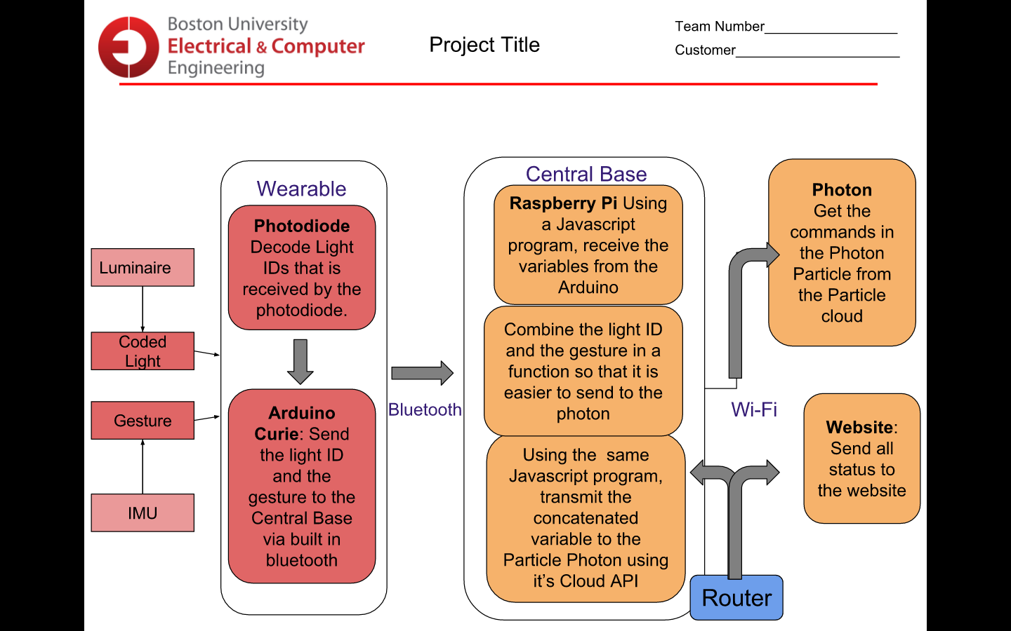

*Figure 3: Gesture mode*

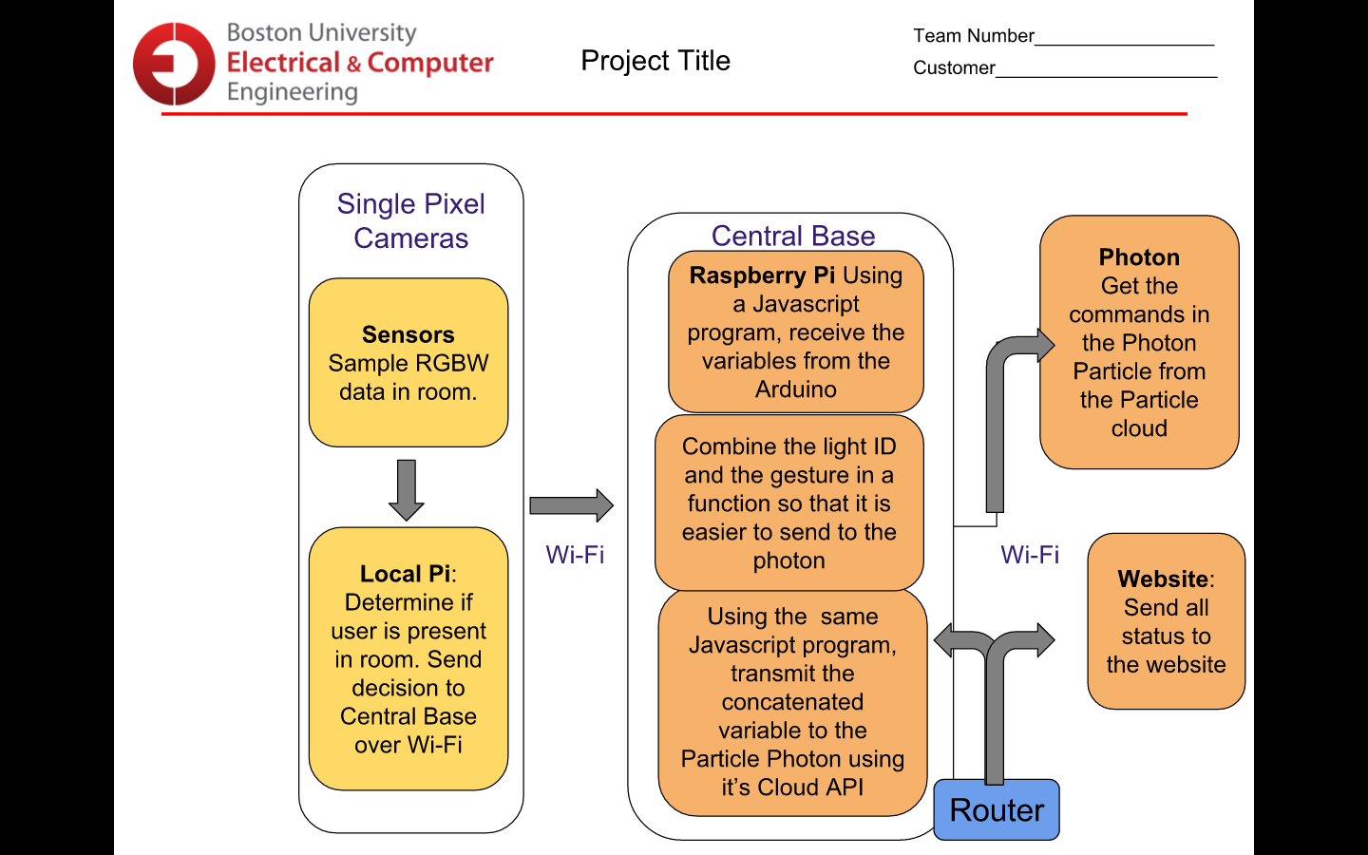

*Figure 4: Adaptive mode*

## 

## 2.2 User interface

The user interacts with the system through the wearable and the website. These components are shown below in Figures 5 and 6.

## Wearable Transceiver

## IMAG0513.jpg

*Figure 5: The wearable transceiver*

## Web Application

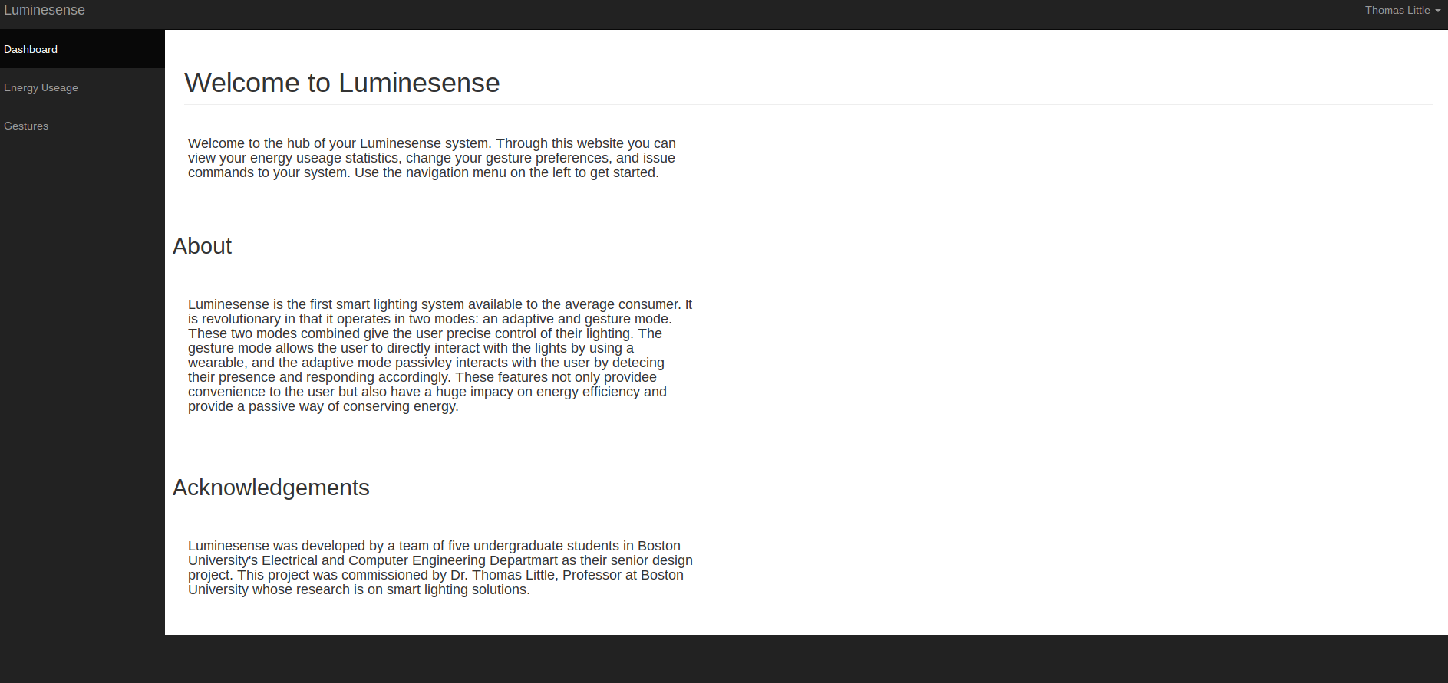

*Figure 6: The homepage of the website*

## 2.3 Physical description.

The luminesense system is split into four main hardware components: the wearable, the central base, the luminaires and the single pixel cameras. These are depicted in the following images.

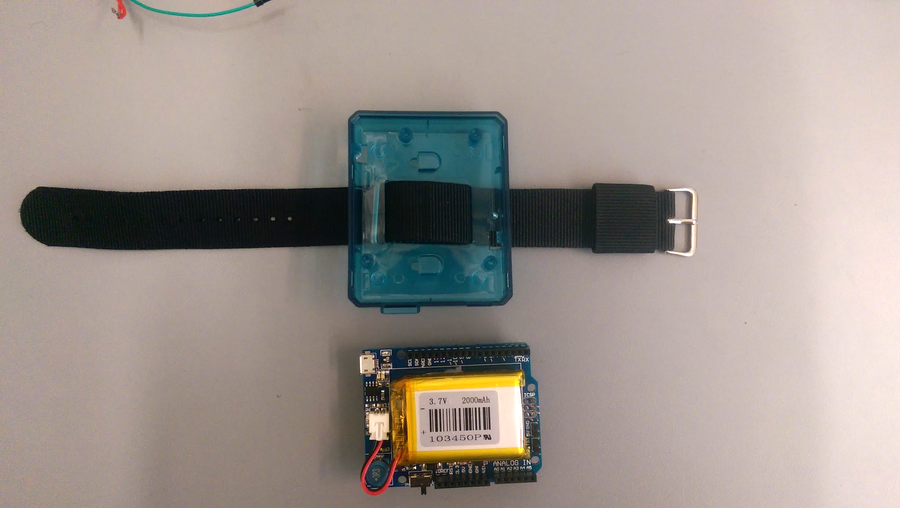

*Figure 7: The wearable, taken out of its case*

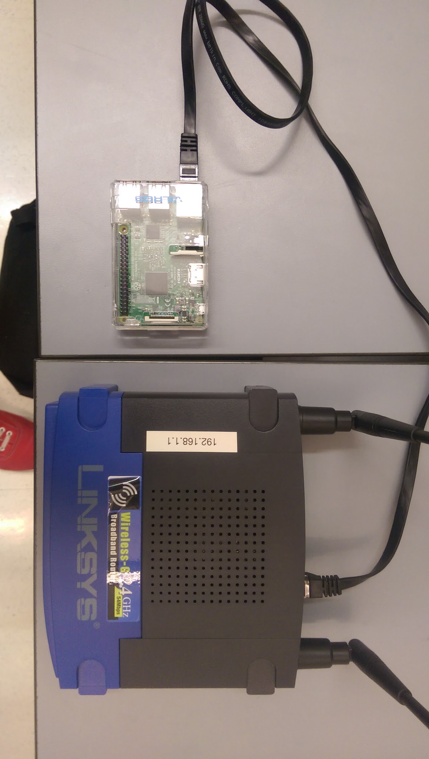

*Figure 8: The Central Base*

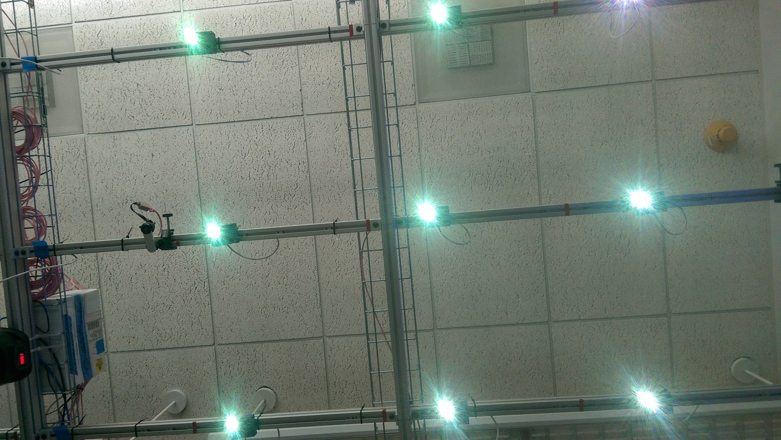

*Figure 9: The luminaires*

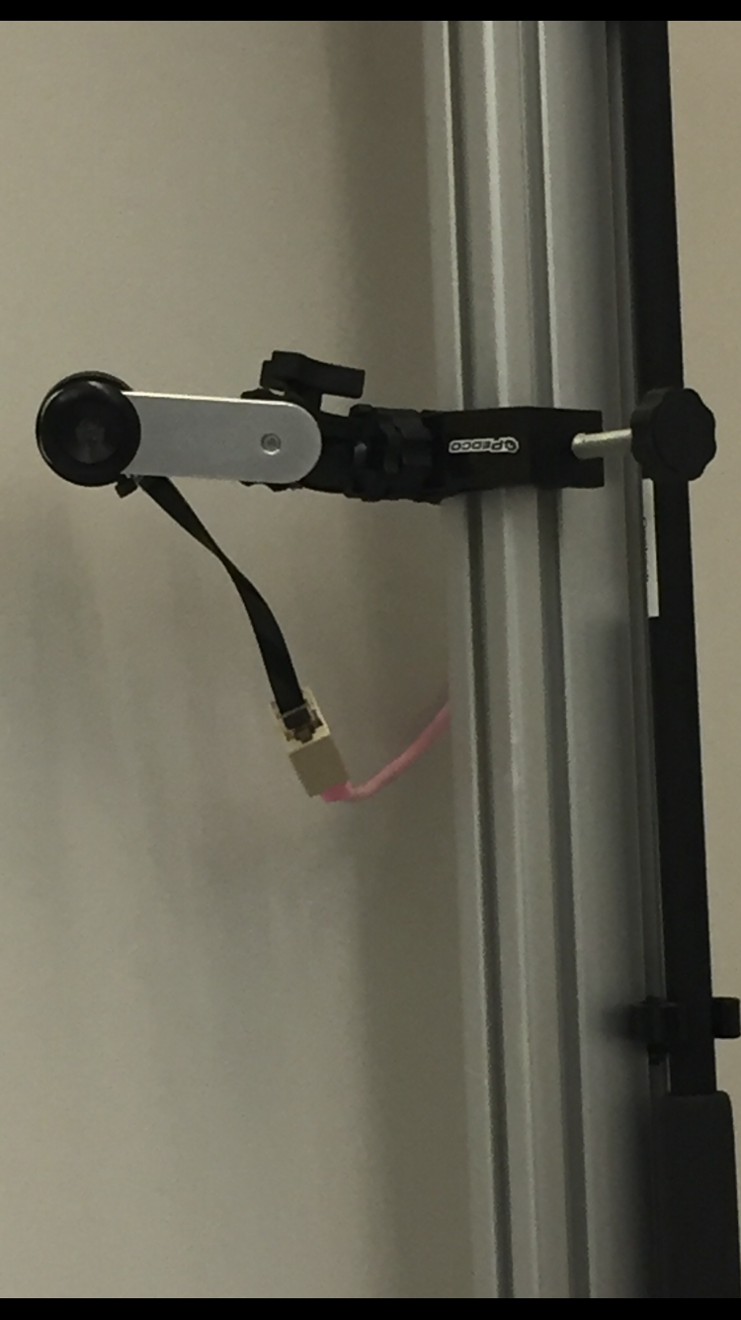

*Figure 10: A Single Pixel Sensor driving adaptive mode*

## 2.4 Installation, setup, and support

## Step 1: Configure network

The user must connect the router in the central base to their network using a standard ethernet cable. This central base must be placed in close proximity of the system in order to ensure a strong bluetooth connection between the base and the wearable. Additionally, the user must ensure that the Raspberry Pi is connected to the router via an ethernet cable.

Initialize the single pixel cameras by connecting to LAN via ethernet. Connect to the local Raspberry Pi directory via ssh and run the MQTTMux2.py file. This launches adaptive mode passive detection.

## Step 2: Power components

Connect the router, Raspberry Pi and cameras to standard outlets. The Raspberry Pi will boot to the default program and begin scanning for the wearable’s BLE peripheral address. To power the wearable, the user must push the switch on the battery to the “on” position. The wearable’s LED will flash green if successful. If the wearable does not power up, then the user must charge the battery using the included USB cable. Once the wearable has been securely strapped to the wrist and powered on, the user may begin to interface with the system.

# 3 Operation of the Project

## 3.1 Operating Mode 1: Normal Operation

Normal operation is characterized by the user engaging with the Luminesense system during a session - where they issue commands with the wearable. In order to to engage in a session and alter specific luminaires, user must perform the following:

1. Press the “Session” button to begin a session
2. Point the wearable (in particular the photodiode) to the desired luminaire
3. Press the “Selection” button to select a luminaire
4. Repeat step 3 until all desired luminaires have been selected
5. Press the “IMU” button to begin the gesture command procedure
6. Perform the gesture
7. Press the “Session” button to end the session

Following the proper execution of these actions, the desired luminaires should change state to what the user specified through their gesture. The default gesture library is detailed below.

|  |  |
| --- | --- |
| **Command** | **Gesture** |
| On | Fist pointing upwards |
| Off | Fist pointing downwards |
| Red | Twist rightwards |
| Blue | Twist leftwards |

*Figure 11: Gesture library*

The adaptive mode is automatic and passive; therefore, the user will not have to perform any special action(s) in order for this mode to function. The user will not need to explicitly interface with the system in this mode, as it will automatically perform its function when the user walks into the room or leaves the room (assuming no other people are present in the room). The user should expect the system to instantaneously respond to their presence.

In order to interact with the website application the user to navigate to <https://luminesense.herokuapp.com> on a web browser. Currently the website does not support login or separate user information, but there are plans to implement this feature in the future. To view the energy usage of their system, the user must navigate to the energy usage page by clicking the link in the sidebar navigation. On that page, the user can view a graph which shows them how much energy the system has used to date.

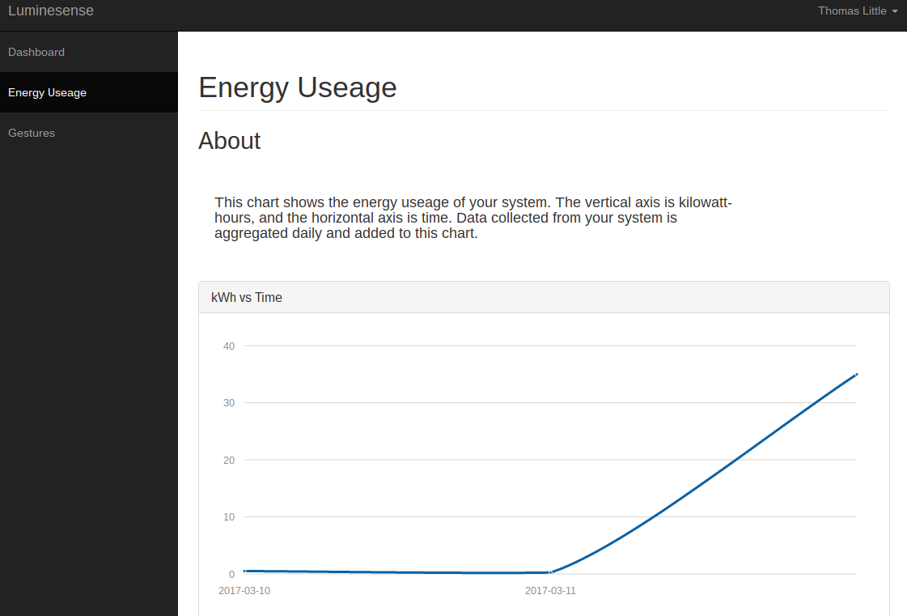

*Figure 12: The energy usage page on the web app*

To update their gesture preferences and/or issue commands to the system through the website, the user must navigate to the gestures page by clicking the corresponding link in the sidebar navigation. The user will find an “on/off” toggle, a color wheel, and a table containing drop down menus. To issue commands to all luminaires, the user can select a color from this color wheel or they can interact with the toggle. This will issue the selected command to all luminaires. Unfortunately, this does not allow the user to precisely select which luminaires they wish to issue commands to.

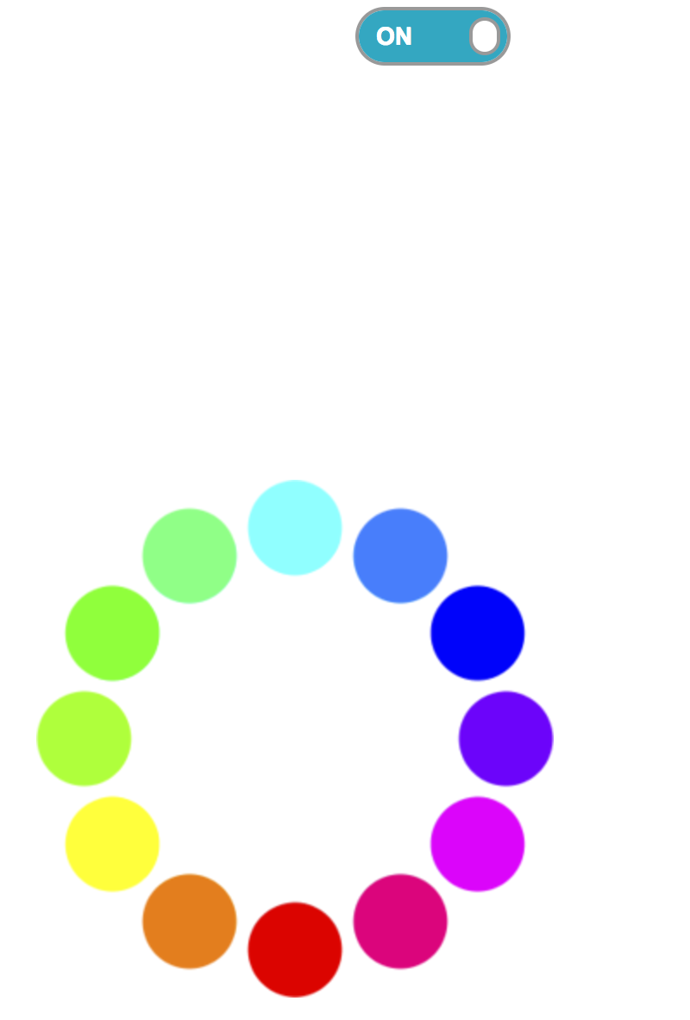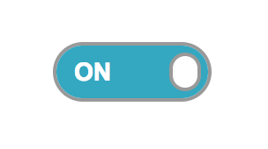

*Figure 13: The gesture control interface on the web app*

To change their gesture preferences, the user should select their desired gesture from the drop down menu for each command and then press the submit button.

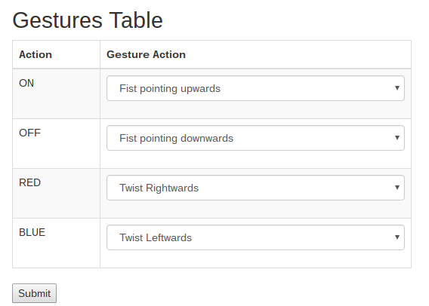

*Figure 14: The gesture preference interface on the web app*

## 

## 3.2 Operating Mode 2: Abnormal Operations

The Luminesense system expects the user to be able to use a functioning wearable device during operation. However, in the case that the user cannot use the wearable, they can still interact with the gesture mode of the system through the web application. Additionally, the adaptive mode will effectively operate the system when the wearable is not in the vicinity. However, there are some cases in which the system will enter an abnormal state, and exhibit unpredictable behavior.

One abnormal state is the scenario where the wearable and central hub fail to maintain a stable BLE connection. This will become apparent when the luminaires do not respond to the user’s commands. To remedy this, the wearable and the Raspberry Pi must be rebooted respectively. Another abnormality is the incorrect selection of the luminaires. To fix the issue, the user must simply restart the session i.e. end the session control and begin a new one.

Another abnormality is the scenario when the Photon loses its Wi-Fi connection with the Central Base. If Wi-Fi connectivity issues are not solved through restarting the wearable and the Raspberry Pi, then there might be too much interference from other devices for the system to function properly. The user should try disabling Bluetooth on other devices to see if this is the case. If none of these steps work, then it is likely that the user’s system is faulty and they should seek a replacement or repair.

## 3.3 Safety Issues

The user should ensure that the wearable is secured snugly to the wrist to prevent the wearable from slipping off during use and possible damaging the user’s property or other people. The user should also ensure that the various components of the system are plugged into surge protectors and take any other precautions to ensure electrical safety, such as keeping the hardware away from water. Should the luminesense system fail entirely, the user should be able to operate the normal lighting in their room with a traditional light switch.

The only user data currently stored in the database is related to their energy usage, gesture preferences, and room occupation. We acknowledge that room occupation can be sensitive information, however this data should be secure in Heroku’s postgreSQL servers.

# Technical Background

The final Luminesense product includes a wearable, a router, a Raspberry Pi, luminaires, and single pixel sensors. All the luminaires are pre set up in the customer’s environment with retro-fitted Photons that control the luminaires.

## Lumianire

The luminaire is an electric light unit consisting of a Cree MC-E LED. The LED is energy efficient - drawing 12 Watts of power - and is capable of producing multi-colored lights (from the visible spectrum) such as red, green blue light. This gives the user more choice when implementing their lighting arrangements. The LEDs contain 5 pins - red, blue, green, white, and ground. These pins are manipulated based on the commands and implement a variety of colors. These pins are modulated to certain PWM frequencies in order to identify each of the luminaires via the Arduino 101’s processing.

## Arduino 101

The Arduino 101, is the latest Arduino board, comprised of Intel’s Curie chip. It consists of an onboard 6-axis IMU, a Bluetooth Low Energy (BLE) module, a photodiode, three push buttons, and a battery pack. This device is responsible for all interactions between the user and the system (in gesture mode). The Arduino contains a C program (wearable_code.ino) required to utilize the additional peripherals. The program samples light signals, performs Fast Fourier transforms (FFT), samples IMU signals, polls button states, and sends data (of size 4 bytes) via BLE. The Arduino contains 196 kB Flash memory and 24 kB SRAM - sufficient to execute computationally complex instructions in reasonable time. The board’s operating voltage and I/O is 3.3V but can tolerate up to 5V. The Arduino program uses the following libraries for data processing and transmission: Madgwick’s, FFT, and BLE Curie. Madgwicks is responsible for analyzing the Arduino board orientation and determining the gesture being performed. The library observes the board orientation with reference to a default setting (lying face down). With that reference, the boards various orientations are calculated and sampled by the IMU to determine its new orientation. Once an appropriate orientation (or gesture) is observed, a switch case is activated, and the IMU gesture is sent as an unsigned char via BLE. FFT is responsible for converting all the analog light signals into the frequency time domain. This way, the frequencies of the observed lights can be configured and determined for luminaire selection. The analog signal is sent into a Radix-2 transform function, where the real and complex values are calculated and the peaks of the signals are produced into a vector of size 128. The sampling frequency of the ADC is used to calculate the largest magnitude/frequency of the vector. To account for accuracy, the transform is performed 100 times and the median of the results becomes the final observed frequency. The frequency is then processed as an id ranging between 1 - 9. Meanwhile BLE Curie initializes the onboard BLE module and prepares the Arduino to transmit the ID and IMU data via BLE to the Central Base. The data sent to the Ras Pi is in various data types - Light ID (integer), IMU gesture (unsigned char), and the various button signals (unsigned char).

## Raspberry Pi 3

Raspberry Pi 3 was used as our central base that provided the link between the wearable and the photon. Raspberry Pi 3 has built in Wifi connection as well as BLE and it was a perfect module for our project. The wearable communicated with the Raspberry Pi 3 using BLE. In the receive_arduino.js, we used noble.js, to communicate with the Arduino 101’s BLE. This communication made it possible to get various information such as getting the “session start”, “gesture start” and “session end” commands. In the same Javascript script, we had the Javascript API for Photon API to send the information to the Photons. The web application gets its energy data from the raspberry pi as well.

## Photon

The Photon is a Wi-Fi enabled microcontroller, responsible for controlling the luminaire states. The C++ program running on the Photon ensures the luminaire can engage with the user in sessions, be identifiable by the user, and change state on command. The Photon is controlled via calls to the Particle API. This API details the device’s unique ID, device functions, and authentication protocols. The Photons receive all commands from the Central Base (relayed from the Arduino 101). If the user presses the session button, all the luminaires enter a flux state, modulating at the assigned frequencies (to allow user interaction). After the selection procedure has ended, the user may engage in gesture performance - changing the luminaire arrangement accordingly. Once the user has changed the arrangement and ended the settings, all altered luminaires persist their new states. Meanwhile, all unchanged luminaire either revert to their previous state, or turn off. All Photons are flashed with the same C++ function (with the exception with the frequency modulation setting).

## Web Application

The Web Application was created with the help of Bootstrap template. It is deployed to the cloud using Heroku. Node.js was used to write the server code for the Web Application and Postgresql was used as our database. Heroku was chosen as AWS might have been an overkill for our project as we just needed to deploy our website. We used Photon’s Javascript API to control the lights and to customize our gestures, we used a post request to send it to the Raspberry Pi. The energy data was pulled from the Raspberry Pi and stored to the database.

## Single Pixel Camera

The adaptive mode is driven by the 11 single pixel sensors located in the SLURP lab. These sensors are indexed 0 -11 (excluding 4) and each continuously sample the room’s thermal image. A Raspberry Pi mounted in the lab receives the thermal data from the sensors and keeps track of adaptive mode information. These two technical choices were essentially made by the client, who required us to use this equipment which was already present in the SLURP lab. Once the Raspberry Pi has initialized the drivers, thermal data streams onto the Pi for analysis. An algorithm implemented in Python on the Pi keeps track of recent data “states”, checking for changes that signify new entrants seen by individual sensors. This approach was decided on because it naturally gave the room status (e.g. empty vs. occupied). If the state remains constant, then either the room is empty or there has been no movement for a period of time. This allows us to set a timer and turn off the lights after several minutes of user inactivity. Python was chosen because of its support on Raspberry Pi and dual-processing integration. Additionally, the automatic control of lights prevents energy from being wasted when nobody is present, a feature that was important to the client.

# Cost Breakdown

# Budget for beta iteration

|  |  |  |  |
| --- | --- | --- | --- |
| **Item** | **Description** | **Quantity** | **Total Cost** |
| 1 | Arduino 101 | 1 | $29.99 |
| 2 | Raspberry Pi 3 | 2 | $80 |
| 3 | Raspberry Pi casing | 1 | $9.99 |
| 4 | Router | 1 | $30.00 |
| 5 | Heroku cloud services | 1 | $7.00 |
| 6 | Battery supply | 1 | $6.95 |
| 7 | Printed circuit board | 1 | $100.00 |
| 8 | Photodiode | 1 | $4.99 |
| 9 | Button | 3 | $6.80 |
| 10 | Wearable case | 1 | $18.85 |
| 11 | Particle Photon* | 16 | $304.00 |
| 12 | Luminaire* | 16 | $96.80 |
| 13 | Single pixel camera system* | 1 | $11,000.00 |
| 14 | Raspberry Pi B | 1 | $35.00 |
|  | Total | **$11,690.36** | |
|  | *Provided by customer |  | |

# Appendices

## Appendix A - Specifications

|  |  |
| --- | --- |
| **Specification** | **Value, range, tolerance, units** |
| Wearable optical sensor range | ~ 20.0 ft |
| Bluetooth Low Energy range | > 30.0 ft |
| Latency | < 1 second |
| Case dimensions | 75.0 mm x 61.6 mm x 15.0mm |
| Wearable weight | 95.0g |
| Power consumption | 3.7V Lithium battery 2000mAh |
| Wearable cost | $56.85 |
| Luminaire quantity | 16 |
| Wi-Fi configuration | Open, WEP, WAPI, WPA and WPA2-PSK |
| Room internal dimensions | 30x30x30ft |
| Voltage Supply - Wearable | 5V |
| Emission wavelengths | Red: 620 nm Green: 520 nm Blue: 450 nm |

## Appendix B – Team Information

Sneha Pradhan is an undergraduate student pursuing a Bachelor’s Degree in Computer Engineering at Boston University. Born and raised in Kathmandu, Nepal, Pradhan strives to makes a difference in the third world countries with the knowledge of technology.

Phone Number: (857) 272-1257

Email: [snehha@bu.edu](mailto:snehha@bu.edu)



Michael Haley is a senior at Boston University, pursuing a Bachelor’s Degree in Computer Engineering. He was born and raised in Quincy, Massachusetts. He will graduate in May 2017.

Phone Number: (857) 939-8554

Email: [mhaley10@bu.edu](mailto:mhaley10@bu.edu)



Caroline Jones is a senior studying Computer Engineering at Boston University. She is from Los Angeles, California and has interned at both the University of Southern California and The Aerospace Corporation. She will start as a full-time employee at The Aerospace Corporation in June 2017 and plans to pursue a Master’s Degree in Computer Science.

Phone number: (818) 919-5444

Email: [ctjones@bu.edu](mailto:ctjones@bu.edu)

Zehua (Harry) Zhao is a senior studying Computer Engineering at Boston University. He is from Henan, China. He transferred to BU from Pine Manor College after completing his first year there. He will be graduating in May 2017 after completing BU’s Computer Engineering course in 3 years.

Phone number: (617) 335-7608

Email: zehuaz@bu.edu

Tanatsigwa Hungwe is a product engineer for adapptED Co. Currently, Tanatsigwa is enrolled in Boston University’s esteemed Computer Engineering undergraduate program. He is from Harare, Zimbabwe and pursuing a minor in Film and Television.

Phone Number: (617) 963-6108

Email: [hungweta@bu.edu](mailto:hungweta@bu.edu)